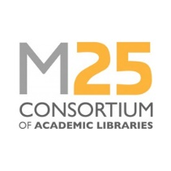
Professional Support Conference Bursary
March 2022
Completed forms should be returned to m25libadmin@london.ac.uk by the closing date stated on the website. Applications will be treated confidentially by the assessment panel.
Name of applicant |  | Date:
Most recent job – please give details of your job title and name of your employer.
State the county where you are resident (see list of eligible counties below)
Guidance for applicants:
- Applicants must be unemployed (not in education, employment or training)
- Applicants must be resident in the region covered by the M25 Consortium (the counties of Berkshire, Bedfordshire, Buckinghamshire, Cambridgeshire, Essex, Hampshire, Hertfordshire, Kent, Norfolk, Oxfordshire, Suffolk, Surrey, East Sussex and West Sussex)
- Applicants must demonstrate how the specific award will benefit their career
- Clearly state your prior experience and how you feel the conference will benefit you and contribute to achieving your future goals
- Please return the Equality and Diversity Monitoring Form with your application. Completion of the form is voluntary, but we would appreciate you taking the time to help us monitor the take-up of the bursary.
- Applications will be evaluated by a small panel from the M25 Steering Group
Applicant’s supporting statement (maximum 500 words):

