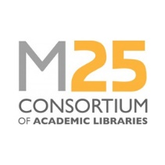
Staff Development Awards 2023-2024
M25 Annual Conference award application form

Completed forms should be returned to m25libadmin@london.ac.uk by midday on Thursday 28 March 2024.

Name of applicant |  | Date:
Current job title
Current employer
Application supported by senior manager in your service | Name:
 | Signature:
 | Date:
Guidance for applicants:
- Applicants must be a library staff member of an M25 Consortium member institution.
- Applications will be evaluated by a small panel from the M25 Steering Group.
- Applicants must demonstrate in their application how the specific award will benefit their career development, and/or will enable them to bring something positive back for their team or library service.

Applicant’s supporting statement (maximum 500 words):

