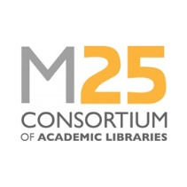
Application Form for M25 Consortium
Staff Development Awards 2026

Name
Position
Employer
Award(s) applying for | cpd25 SLA Conference
Award(s) applying for | M25 Consortium Annual Conference
Award(s) applying for | cpd25 Cataloguing with Confidence Training
Award(s) applying for | cpd25 One Day Training (event(s) of your choice)
Please provide your reasons for applying including how attendance will contribute to your professional development and bring benefit to your team/library service

(maximum 500 words):

I confirm that I have notified my line manager of this application and if it is successful, I will make the appropriate arrangements with my employer to enable attendance at my chosen event.

I confirm that I have read and understood the Terms and Conditions of the Staff Development Awards.

Signed
Date

Please return your completed application form to the M25 Operations Manager by emailing it to m25libadmin@london.ac.uk no later than Wednesday 11 March 2026.

