Libraries & Collections at King’s College London
Case Study: Wellbeing Room at Franklin-Wilkins Library, Waterloo Campus
Over the last decade King’s College London has positioned sustainability as a core strategic principle. The Libraries & Collections team support this institutional strategy, as libraries’ work closely aligns with several of the UN’s 17 Sustainable Development Goals. This case study describes our creation of a library Wellbeing Room, aligning with goals 3 and 12:
Goal 3: Good Health & Wellbeing
A library Wellbeing room:
- provides a quiet third space within the crowded and often noisy library space
- balances the need for private sanctuary with an opportunity for social connection
- promotes the necessity of study breaks
- increases support through timetabled activities and signposts to support during stressful periods

Goal 12: Responsible Consumption & Production
The new room:
- fulfils the need for flexible and accessible spaces on lower floors
- features re-used and recycled furniture in a repurposed redundant space
- hosts crafting sessions from waste materials and sustainability-focussed sessions during Green Libraries Week

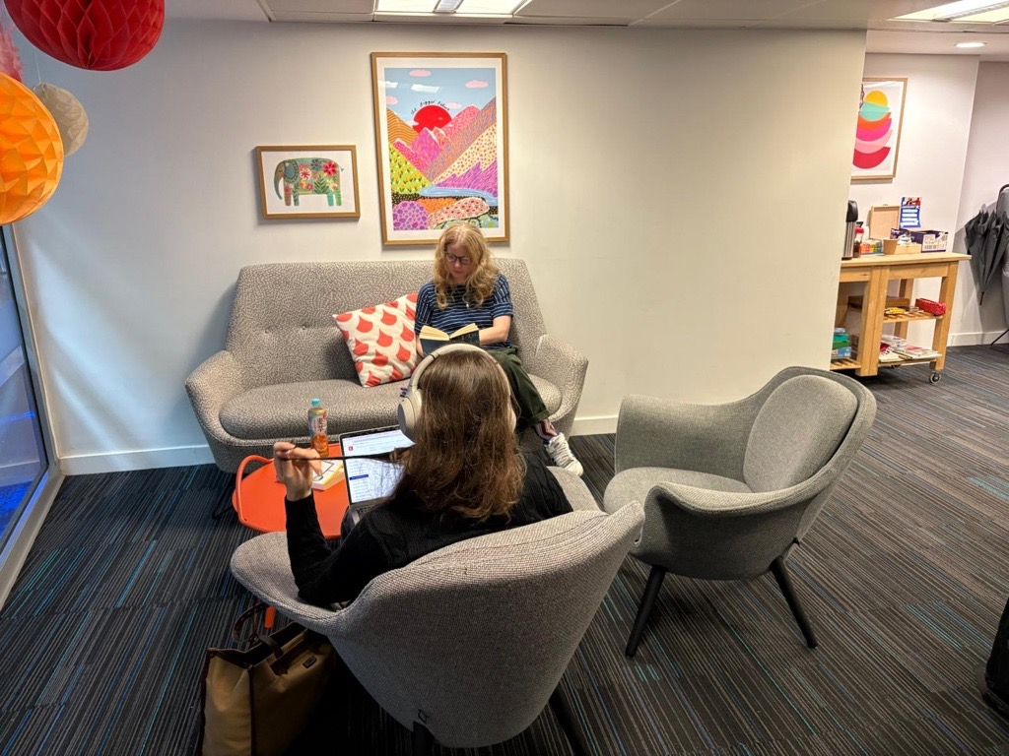

Background
In September 2024 we opened a new student Wellbeing room at our Waterloo library. A large room had been left empty after the decant of short loans into the main collection. It was a prime location: right at the entrance of the library with a large people-watching window but with enough cosy corners to accommodate those who wanted privacy.
The decision about what to do with the suddenly empty room was an easy one. A recent student-led project about wellbeing had told us several important things:
- Students want more wellbeing spaces in their libraries
- They want them to be accessible
- They want them to facilitate meeting others and making friends
There was also a need for a pastoral care element for the Wellbeing room. Students in the Waterloo library had been in bringing suitcases of belongings and sleeping in secluded areas of the library for days at a time. While we have a robust Student of Concern process to help these students, we also needed a space to refer napping students where they could be seen by staff, to monitor if the nap was a quick refresh or warranted concern. The proposed location had the further bonus of being in view of the library enquiry counter and passing staff.
Preparing the room
To signal the room was not for study, but for rest, relaxation and community, we:
- removed all shelving and study furniture, installing coffee tables, armchairs and sofas
- removed cluttered pinboards and student fliers. The only advertising in the room is for the university’s own Wellbeing support services and posters for Wellbeing reading lists
- covered over the room’s power sockets and installed a charging station to encourage screen breaks
- placed signage both inside and out, stating the purpose of the room and reminding users to study elsewhere
- filled the room with jigsaws, novels, colouring books and board games
The space was created cheaply and sustainably, at little cost to L&C (apart from the cost to remove the RFID gates and a small budget for cushions and pictures). Estates colleagues donated the lightly used furniture and painted the room with paint left over from a summer refresh. The used books, games and activities were donated by library staff.

Feedback and lessons learned
The room was an immediate success. From opening day, students began to use it for its intended purpose, with very few using the space to study. On a typical day you can find at least two students napping on one of the sofas, a few doing a puzzle together and a friend group catching up with each other.
Student feedback included:
‘There are no other spaces like this on campus’
‘Can we have more crafting sessions in here please?’
‘I was going to do something else in my lunch break but I’d rather come here and take a nap’
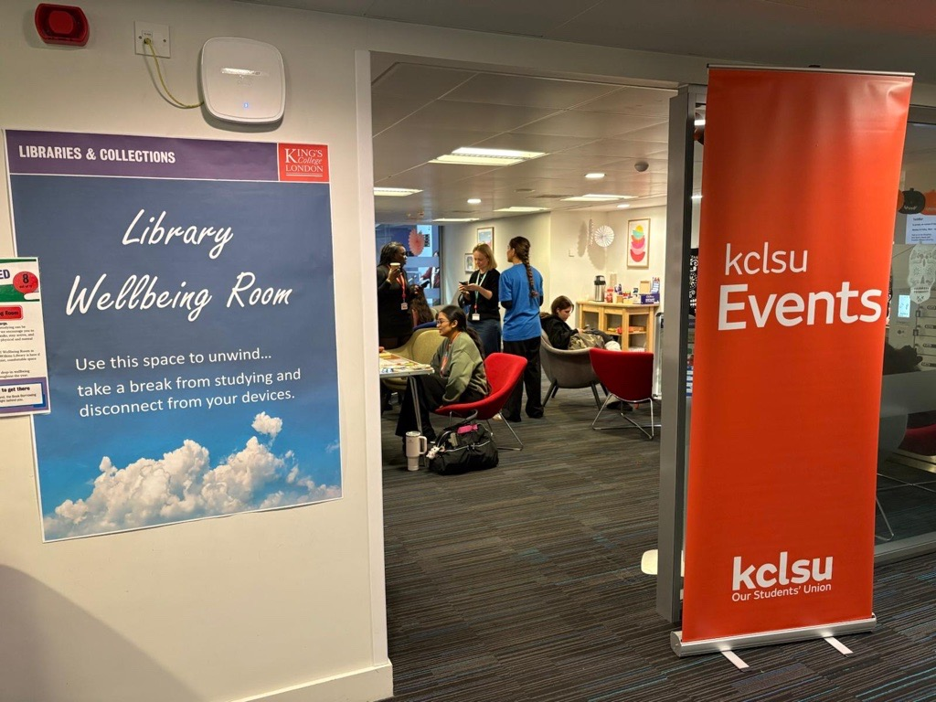

Students told us they want regular crafting sessions in the room where they can learn a skill and make friends. In the first year we held these sessions every few months, led by library staff. They attracted about 10 students per session, mainly international students, but limited staff availability meant we had to scale back in 2026. We have now opened the space to student societies and the Wellbeing team, who visit once a week to promote their service and lead a craft session. This fulfils the need for structured activities while freeing stretched library staff. However, students would prefer daily, not weekly activities and we’re working towards that.
During busy times, the room can be in danger of being hi-jacked by groups looking to have a loud study session. This risk can be reduced by keeping the room tidy and the furniture grouped in small clusters around coffee tables to make the room look more like a space to relax. Any desk-height tables moved into the room by students are moved out immediately by vigilant staff!
In the early days, books and cushions would mysteriously disappear from the room. The cushions were eventually located in other areas of the library, but the self-development books never returned. As all the books were donated, we decided to accept these would go, refreshing them each week with staff bringing them in from various donation hubs. This also keeps the collection fresh and negates any worry about monitoring the donations.

Future plans
- Students like to leave positive messages for each other so we will be investigating a chalkboard, message wall or other means to facilitate this
- Our jigsaws now all have missing pieces and these are harder to find second-hand than books – we’re considering a Jigsaw Donation day for staff
- We will be making the room bookable online, promoting it to the King’s community and thereby increasing the selection of events and offerings hosted in the room. Library staff will continue to run events during Welcome Week and Green Libraries Week
- We hope to create a similar room at least one of our other library sites!

Libraries & Collections Sustainability Working Group
King’s College London

